Ideal Gas and Kinetic of Gases
TL;DRs
An OS Creation of Shazin

Gas Laws:
Boyle’s Law:
“If Temperature is constant , the volume of a gas with a specific mass is disproportional to the pressure applied to the gas.”

Mathematical interpretation:
Charles’s Law:
“ In a constant pressure the volume of a gas is proportional to it’s temperature.”

Mathematical implementation:

Gay-Lussac’s Law:
“In a constant volume and mass pressure increases in a proportional rate to temperature”

Mathematical implementation:

Avogadro’s Law:
“ In a constant pressure and temperature the volume is directly proportional to the number of moles of the gas”

Mathematical implementation:

Graham’s Law (Law for Diffusion Rate):
“ Diffusion rate is inversely proportional (disproportional) to the square root of it’s molar mass”

Mathematical implementation:
**Note: The molar mass is actually the mass of an atom. It means it is the mass given in the periodic table not the mass of of the sample.

Combined Gas Law:

Equation of density of a Gas:

Ideal Gas Equation:

Here, P = Pressure ; V = Volume ; n = Number of Moles ; T = Temperature ; R = Ideal Gas Constant = 8.314 JK⁻¹ mole⁻¹ ;

Pressure of Fluid:
The pressure effective in an object drowned in a fluid is,
Here, h = height of the fluid, ρ = density of the fluid and g = gravitational acceleration.

Tips for Math related to Pressure in Fluid:

Tip:1 If the the pressure of atmosphere is given P₁ then the pressure in the fluid P₂ should be

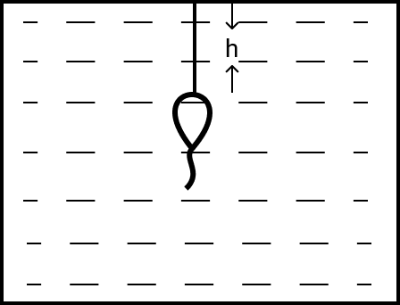

Tip:2 If The pressure of a balloon in air is P₁ , it’s pressure when drowning in a fluid should be

P₂ = P₁ + hρg

